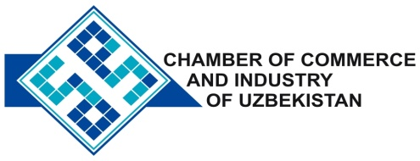

**Commercial offer of Uzbek Products to Foreign Buyer**

Dear Sirs, №SHP-021

We offer quotation of Uzbek companies LLC "Sedat Trico Tashkent".

**Information about the company:**

Company LLC "Sedat Trico Tashkent" was founded in 2006. The company specializes in the production of knitted fabrics, cords, etc.

**List of products:**

Knitted fabric: kulirnaya surface, futernoe weave plush weave, weaves futernoe trehnitochnoe, interlock, rib weave, jacquard weave with fine patterns.

Different types of cord: ekstrafor, cordon trees, rubber cords

**Terms of delivery:** FCA Tashkent

If you are interested, we are happy to provide additional information in accordance with your request.

E-mail: export@chamber.uz

Website: www.chamber.uz

Export Promotion Department.

Chamber of Commerce of the Republic of Uzbekistan.